Scottish Swedish Society – Skotsksvenska föreningen
AGM 2021 held by Zoom, 8pm on Friday 30 April 2021

Welcome – Gunilla. Attendance and Apologies (see below)
There was no AGM in 2020 due to Covid but an Annual Report was sent out and is available on the Website.
Chair's address, Gunilla
Little did we know last year that we still would not be able to meet up by now and have our AGM in the usual manner. However, over the last year we have been using ZOOM and other platforms and we hope that this is going to work well for us tonight. Unfortunately, we shall not be able to provide our customary lunch in this way! Jenny is our ZOOM host and we thank her for that.
Needless to say, the Society’s activity level has been reduced this year since we have not been able to meet up in person, but we have done our best to provide some programme. We held two successful meetings by Zoom, which the Event Managers describe in more detail in their report. We have also passed on important information by emails, on the website and on Facebook. They have covered a range of topics, ranging from some of the consequences of Brexit that are likely to be of particular interest to our members, through the appointment of a new Consul in Edinburgh and details of Swedish Church virtual visits to guidance on Levnadsintyg during lockdown. So, quite a range of information which we hope has proved useful. The website has been updated where appropriate and is well worth a look every so often. There has, in addition, been a fair amount of informal support given by phone calls, visits when possible not to mention deliveries of cinnamon buns.
We must now hope that life will return to some sort of normality before long. The Committee is thinking hard about a suitable programme and we are as always very open to suggestions.

Committee members, Introduction those who were present
Chair Gunilla Hampson
Co-chair: Conny Petterson
Treasurer: Stephen Hampson
Secretary: Kerstin Phillips
Website: Conny Petterson and Lina Weckner
Facebook: Harris Keillar
Events: Lina Weckner, Maya Vuckovic, Jenny Karlsson

Website demonstration, Jenny
Treasurer's report, Stephen
The annual accounts for the year 2020-21 are shown at the end of the report. Once again, John Phillips has very kindly examined them and reported on his conclusions.
The Society’s financial position reflects the limited scope for activities as a result of Covid restrictions. We had neither income nor expenditure on events, normally the largest items. Our income was limited to subscriptions and our expenditure to a few items of an administrative nature.
The Committee took the view that we should neither remind members who did not renew their subscriptions nor take them off the membership list. Consequently our subscription income was somewhat reduced. The same policy is being followed in 2021-22. We are especially grateful to all those who have continued to make subscription payments.
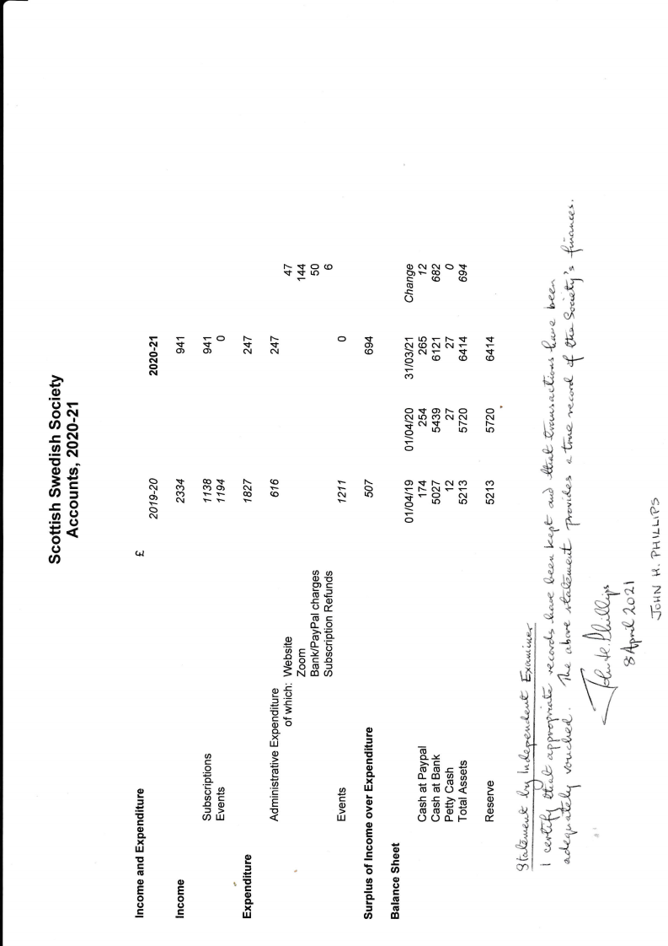
Expenditure fell faster than income and our surplus therefore increased. Our cash reserves now approach 3 years normal expenditure. The Committee hopes that it will be possible to use part of this surplus towards events at a reduced price when Covid restrictions permit.

Secretary’s report, Kerstin
Since the first lock-down in March 2020 due to Covid we have not been able to hold any of our meetings so the work as secretary has not been onerous. There has been very little travel in or out of Scotland, no Swedish performing groups asking for help with visits to Scotland. I receive a variety of questions by email about living and working in Scotland. Most of these requests I am able to send on to different websites that may be helpful. The Swedish Consul, Mike Christopherson based in Edinburgh has been very helpful and has dealt with a variety of issues. He has been exceptionally helpful with certifying Levnadsintyg for some who could not travel to the Consulate.

Events since spring 2020. Several events were planned but because of Covid, they could not happen. Two enjoyable meetings via Zoom were held in autumn 2020. We hope to be able to organise some Zoom events in the future.

In October we arranged an event Sommarstuga: The Swedish Dream where we discussed the things to think about if you are looking to buy or maintain a summer house in Sweden.

In November we had another event Träffa Mike Christopherson the new Swedish consul in Edinburgh. He gave an update on his tole as Consul and answered questions related to consulate services and Brexit. The notes are available on https://www.scottishswedish.org/category/latest-news/

Future events, Lucia celebration in person is still uncertain but the Swedish Church in London has provisionally planned to come here on Sunday 5th December.
There is as yet no date or venue for Midsummer picnic and dancing. Any suggestions for a possible venue would be very welcome!
Book reading groups, 2020 – 2021
At the moment members live in or around Edinburgh and before Covid, used to meet in one another’s homes. Since Covid, members are in contact with each other via Zoom.
Since Brexit, Bokus who in the past have provided us with the paperbacks is no longer able to send books to Britain and there is no indication as to when they will be able to do so. Bokon.se can provide ebooks and audio books in Swedish. Adlibris.com also sell ebooks as well as audio books. It can be worth comparing prices from these two. AbeBooks.co.uk has some Swedish books and the price is similar to what they would be in Sweden.

- Bokcirkeln read books by Swedish authors in Swedish and meet in the evening every month to discuss the book and for the last 12 months we have met by Zoom. We speak Swedish during out meetings. We read a mixture of current or recently published non-fiction and fiction books, often books that give us an insight to life in Sweden in the past or currently. The non-fiction books have included natural history, philosophy, adventurous explorations and biographies. Because of our different backgrounds and life experiences, the discussions are often wide ranging and stimulating, often reflecting on our own memories of living in Sweden. If interested, contact Kerstin Phillips.

- Book reading group reading Swedish authors in Swedish meet in the afternoon. The group reads a variety of books and speak Swedish when meeting. Since Covid the group has not had regular meetings but have enjoyed meeting each other by Zoom to discuss current issues and sharing what is happening. If you are interested to find out more, contact Christina Coltart.

- Book reading group reading Swedish authors in translation to English. This group enables some who are not are not bi-lingual to enjoy discussing and studying Swedish literature. This group used to meet mid-week every sixth weeks in the afternoon in their homes but now meet intermittently via Zoom. They read both classic and newly published Swedish books in translation and discuss in English. Recently they have read several historical biographies books about Swedes active abroad. They focus on the language and the quality of the translator. Some books recently have had enthusiastic comments whereas others have been very disappointing. If you are interested to find out more, contact Carina Dahlstrom-Mair

- New book reading group also reading in Swedish is being organised by Anna Christopherson. They will meet in the evenings.

Swedish Church in London organised two Zoom meetings for Swedes living in Scotland. The mid-day meetings were not well attended. Kerstin has been contacted about dates for Lucia in Edinburgh.
Swedish conversation group was started by Angus Mc Carter and he is the organiser. He writes: The Swedish Conversation group is on Zoom at 8pm every Tuesday evening. To join email angus.mccarter@gmail.com to be added to our email list. The group is very relaxed and informal. All abilities welcome. We would also like if some native/fluent speakers would join us to help the conversation move along. Harris to publicise on Facebook

Scottish Swedish Facebook group is run by Harris. It has 609 members. Relatively few people are asking to join and he is very strict about ensuring they answer his questions so we don't get any potential scammers. It is a very useful for getting information out very quickly, though not sure how effective it is at generating business for face to face meetings.

Swedish School (not part of SSS but included here for general information) – Lina. The Swedish School in Scotland offers 10 lessons per term for children from the year they turn 6. There are currently 41 children and three teachers. Since the lock down the school has offered classes via Zoom. For more information and to place your child in the queue please visit www.svenskaskolforeningeniskottland.co.uk.

The AGM was formally closed here.
Discussions followed. Britta asked about possible information about driving a car to their house in Sweden with their dogs in June. They had no problems last summer taking the dogs to Sweden via the Netherlands and Denmark but now after Brexit, things seem complicated, uncertain and possibly very expensive. They will drive through two different EU countries and enter Sweden, each having their own rules and later return the same way and enter Britain and Scotland with possible quarantine requirements.

Suggestions for future events. Whisky tasting which would cost about £30 per person for samples. A Swedish author talking in Sweden via Zoom about his work. A meal at Söderbergs or a picnic with goodies from them eaten outdoors. Christmas meal at IKEA. A talk by the manager of Edinburgh IKEA. Ask Swedes to tell their stories about living in Scotland or in Sweden. John Gilmour to talk about Sweden in the second world war.
Valborg music. We listened to Studentsångare from Lund who sang via internet.

Attendance Christina Coltart, Caroline Dow, Gunilla Hampson, Nickolas Hampson, Stephen Hampson, Jenny Karlsson, Harris Keillar, Arthur Lightfoot, John Phillips, Kerstin Phillips, David Sugdon, Britta Sugdon, Maya Vuckovic, Lina Weckner

Apologies: Jeanette de Geer Nairn and Susan Kirkwood

